**Excel Assignment 3**

1. What do you mean by “Relative Cell Referencing” in MS Excel and “Absolute cell referencing”?
   1. Relative cell referencing – keeps on changing when we copied & pasted to different cells
   2. Absolute cell referencing – Its remains concrete\constant & no mater where we place it, it wont change
2. How to secure an excel workbook, demonstrate it with an example.
   1. To prevent other users from viewing hidden worksheets, adding, moving, deleting, or hiding worksheets, and renaming worksheets, you can protect the structure of your Excel workbook with a password
3. Explain the pivot tables and their implementations.
   1. A PivotTable is an interactive way to quickly summarize large amounts of data. You can use a PivotTable to analyze numerical data in detail, and answer unanticipated questions about your data. It helps to bring graphical representation for the relevant data set in quick way
4. Explain lookup in excel with suitable examples.
   1. Make us to take the relevant data by the intersection of Column & row

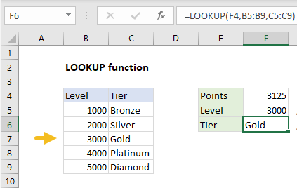

1. What is Data validation, and how to implement it in Excel?
   1. Data validation in Excel is a technique that restricts user input in a worksheet. It is often used to limit user entry

